SEED: 222

Preprocessing: None

Parameters:

Mean Square Root Error:

1 -0.4460 (+/-0.2849) for {'C': 10, 'cache_size': 0.3, 'decision_function_shape': 'ovo', 'gamma': 'scale', 'kernel': 'rbf', 'probability': True, 'shrinking': True, 'tol': 0.001}

Models:

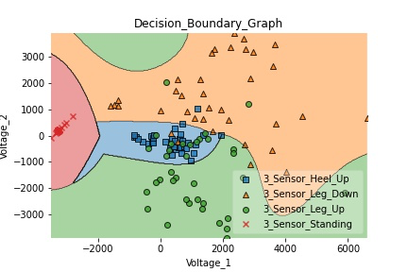

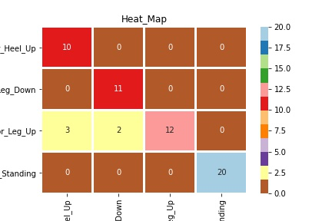

Metrics**:**

1st in everything